- Homelessness is caused by…
Loss of loved ones
Job loss
Domestic violence
Divorce
Family disputes
Depression
Untreated mental illness
Post-traumatic stress disorder
Addiction
Physical Disabilities

STATISTICS:
- 20-25% of single adults that are homeless suffer from severe and persistent mental illness
- More than half of the homeless are families with children

QUOTES:
- “We think sometimes that poverty is only being hungry, naked and homeless. The poverty of being unwanted, unloved and uncared for is the greatest poverty. We must start in our own homes to remedy this kind of poverty.”
- Mother Teresa

- “If a free society cannot help the many who are poor, it cannot save the few who are rich.”
- John F. Kennedy

WHAT’S THEIR STORY?...

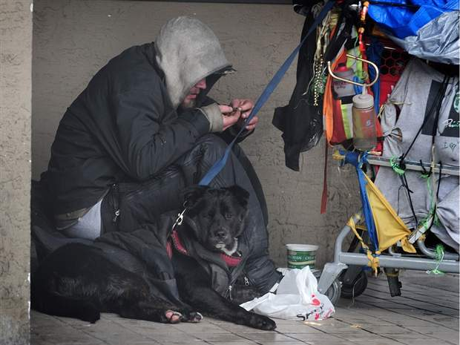 | 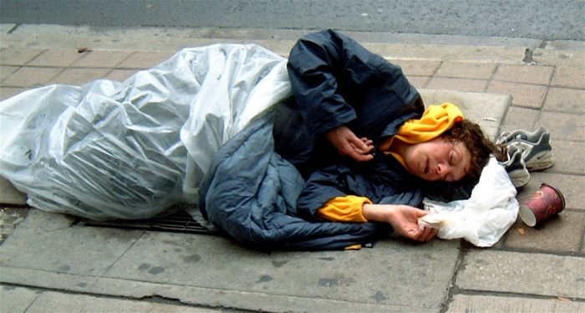 | 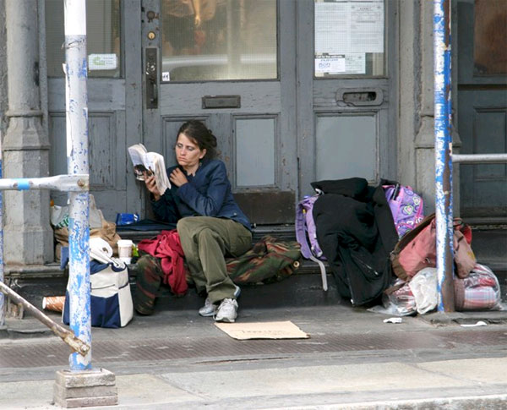 | 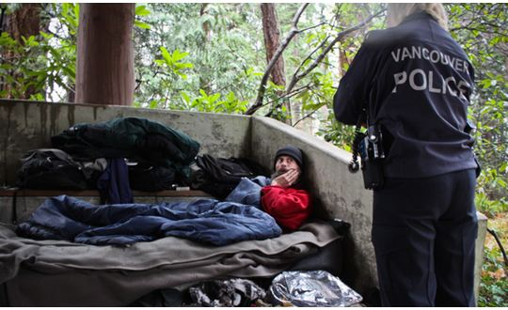
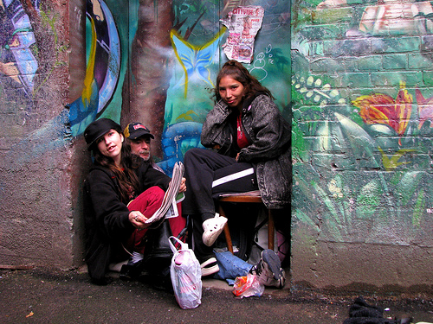 | 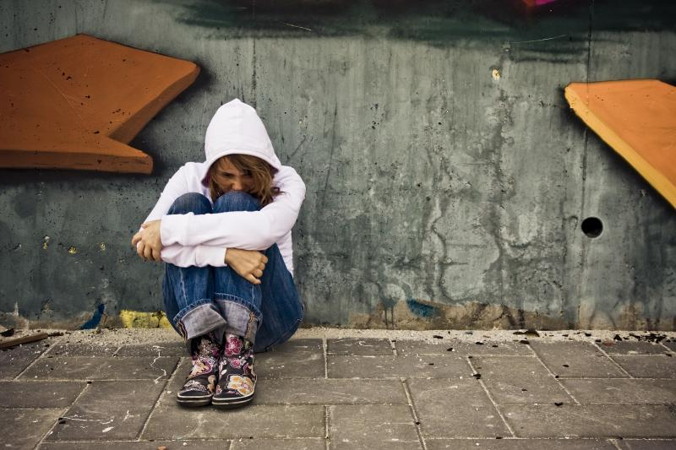 | 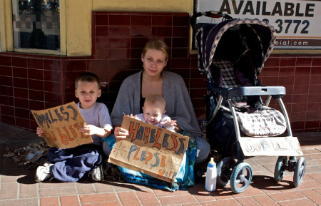 | 